**Business Analyst Capstone Project:**

**E-Fixed Deposits**

**Overview and Summary:**

One of the leading banks across the globe is ABC Bank. It has a presence in 56 countries in the world.

ABC Bank currently has a manual option to create fixed deposits. The bank users go to the nearest ABC Bank branch and create a fixed deposit. ABC Bank has a future vision of being a 100% online bank and wants to do away with all its manual banking processes. They have identified the need to create e-fixed deposits.

ABC Bank currently wants to introduce this to their existing bank users with a future plan of introducing this feature to non-ABC Bank users.

Advantages of opening an FD online

* **Easy and less time-consuming**: An online FD can eliminate the process of visiting the bank physically and makes the process of creating an FD a straightforward and hassle-free process.
* **Easy payment:**Paying for the FD is extremely easy and can be done directly through net banking that makes the process of payment very convenient. All that is required is to transfer the money from the savings account to the respective FD account.
* **Easy renewal and closure:** Once an FD account is opened online, it is possible to renew and close the deposit online instantly. Therefore, it eliminates the need to go to the bank for any of these purposes.

ABC Bank invited Business Analysts trained at Simplilearn to capture the requirements to create this feature on their existing web portal.

**Project Task: Week 1 and Week 2 (This is on the Business Analysis concepts taught)**

1. Identifying Stakeholders – Create a list of stakeholders (as taught in the Business Analysis Planning and Monitoring Knowledge Area)

**List of Stakeholders:**

* **ABC bank New/Existing users**
* **ABC bank employees**
* **ABC bank managers**
* **Testor**
* **Business Analyst**
* **Create As-Is and Future Process map (using flowcharts). You can use any of the popular tools in the market like Microsoft Visio, Lucid Chart, Creately, Pidoco, or Balsamiq**

**As-in process:**

**Future process:**

* As a Business Analyst working on this project, find out the scope of online FD creation. Write down the main features that need to be developed.

**Scope of the ABC Bank online FD creation and main features that need to be developed:**

* The new online feature of E-fixed deposits on ABC online/mobile banking should be strictly restricted to new and existing users.
* The system should be enabled for location so that it can be accessed and get the location of the users for reference purposes.
* The FD calculator should be featured in a way that it can get FD rates according to the age mentioned and consider Senior FD users' rates for over 60 years.
* The system should be able to generate reports of the FDs made over a while to make business decisions.
* Once the FD is made online, a confirmation step should be provided to choose the communication through via Email or Mobile contact.
* **Write the in-scope and out-of-scope items for this software.**

**In-scope:**

* Users should be able to have access to the new feature of E-fixed deposits for both existing and new users.
* The system should display all the required documents to open an FD online.
* The system should be automated regularly and display FD rates according to ABC norms for Normal and Senior citizen users.
* The system should have a fixed calculator feature where user can able to calculate the mature amount when Age and FD amount details are entered.
* The user should be able to choose the account to debit in case of multiple bank accounts.
* There should be an option to create Joint FDs. In this case, the name of the other customer along with his/her SSN details should be taken.
* Users should have an option to enter a nominee. In case of a nominee, the age should be asked. If the nominee is a minor, then guardian details need to be taken.
* Once an FD is created, the user should be emailed a copy which should be reflected in online and mobile banking accounts.
* The managers should be able to generate reports to value different FDs over some time and the number of FDs as well.

**Out-of-scope:**

* Any individual can open an FD in the ABC bank without having a bank account.
* Users can open an FD without having all the necessary documents if they have credibility.
* Giving access to the reports to all the users which have information of the FDs made.
* System scheduling timings to open an FD online.
* **Write out the business requirements, both functional and non-functional requirements.**

**Functional requirements:**

* The bank users (both new and existing) should be able to access the new feature of creating FD using online or mobile banking accounts.
* The system should be able to show the checklist or required documents to open an FD with ABC bank such as a Savings account, and an online banking/mobile banking account.
* The FD rates should be displayed as per the ABC norms to the users using this feature.
* There should be a fixed deposit calculator. The user will enter his/her age and the amount he/she wants to create an FD for. The FD calculator will display the maturity amount.
* In cases where a user has multiple bank accounts, he/she should be able to select which account to debit for the FD
* Users should be able to select one of the two maturity instructions.
* Renew FD for the same tenor
* Credit maturity amount to my savings or current account.
* There should be an option to create Joint FDs. In this case, the name of the other customer along with his/her SSN details should be taken.
* Users should have an option to enter a nominee. In the case of a nominee, the age should be asked. If the nominee is a minor, then guardian details need to be taken.
* Once the FD is created. The user should be emailed a PDF copy of the FD.
* The PDF copy of the FD generated should be reflected in the online banking account and mobile banking account as well.
* The bank wants to generate certain reports:
* Total value of FDs for users with tenor of less than 6 months.
* Total value of FDs for senior citizens with tenor of less than 6 months.
* Total value of FDs for users with tenor of between 6 months 1 day and 1 year.
* Total value of FDs for senior citizens with tenor of between 6 months 1 day and 1 year.
* Number of FDs that are more than 1.5 Million USD for normal users.
* Number of FDs that are more than 1.5 Million USD for senior citizen users.

**Non-functional Requirements:**

* The ABC bank website and mobile banking app should be available at all times except under maintenance.
* The new software feature of E-fixed deposits should be in full progress for both new and existing users without any technical glitches.
* The screen should be self-explanatory and user-friendly.
* Highly secure, scalable, and reliable.
* The system should have regular maintenance.

**Draw wireframes or mock screens for any two of the features. Use the technique prototyping or wireframing that is taught in the training. You can use any of the wireframing tools like Microsoft PowerPoint, Microsoft Word, Balsamiq, Sketch, Adobe XD, Adobe ILLustrator, Figma, UXPin, InVision Studio, Invision Freehand, or Moqups.**

**MOCK SCREEN 1:**

**MOCK SCREEN 2:**

**Project Task: Week 2 (This is on the agile scrum concepts taught)**

1. Make a product backlog of user stories for the given case study. User Stories should be in the format of As a <type of user>, I want <goal> so that <reason>
2. For each story, write the acceptance criteria.

**Project Task: Week 4 (This is on the Tableau concepts taught)**

Mock data used for creating the Tableau dashboard:

* **Create a dashboard for senior management to view FDs created over the last 6 months. Make assumptions as appropriate and create the dashboard using your own mock data. For any missing data, make your assumptions to create mock data. Write down the assumptions as well.**

Tableau link: [E-fixed deposits capstone project | Tableau Public](https://public.tableau.com/app/profile/poojitha.prathipati/viz/E-fixeddepositscapstoneproject/Dashboard1)

**Excel task:**

**Question 1:**

1. Create a bar graph showing the FD sales for different periods of investment. Draw two bar graphs: one for normal users and the other for senior citizens. label the chart drawn correctly so that senior management gets a clear report of sales.

**Bar graph for Normal Users:** A bar graph has been drawn from the data of period and User FDs for normal users.

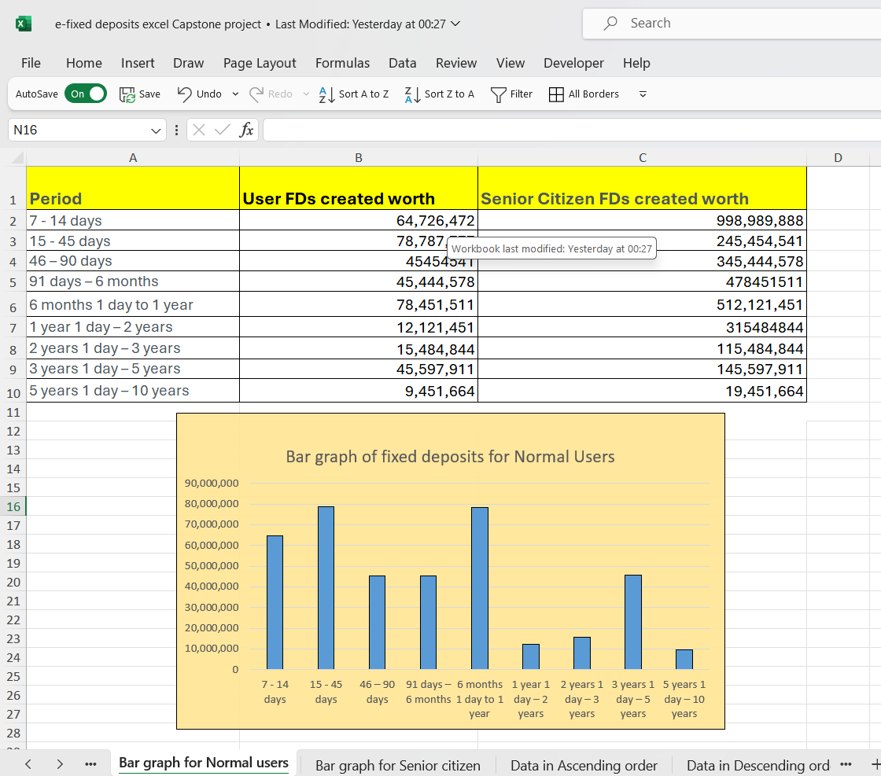

**Bar graph for Senior Citizen Users:** A bar graph has been drawn from the data of period and Senior citizen FDs worth created.

**2. Arrange the data above in Excel in ascending and descending order.**

**Ascending order:**

**Descending order:**

**Question 2**

* Using vlookup for product code HDH, find the rate for senior citizens for amounts less than 2 crores.

VLOOKUP formula used: =VLOOKUP(B4,B4:F12,3,FALSE)

* Using vlookup for product code YFF, find the rate for senior citizens for amounts less than 2 crores.

VLOOKUP formula used: =VLOOKUP(B12,B4:F12,3,FALSE)